Question 1: (6 marks)
Write a program in Java using linked list to manage information about students. Variables used to store information about a bus are:
- code - the code of a student (character string).
- name - the name of a student (character string).
- age - the age of a student (integer value).
- mark - the mark of a student (double value).
Conditions for valid data: The code does not contain 'B' character and mark must be between 0 and 10.
You should write the MyList class (and other necessary classes), which is a linked list data structure to store student information (The type of linked list is optional). The following functions should be incuded in the MyList class:
- void clear() - clear the list.
- void add(Student x) - add student object x to the end of the list.
- void add(String code1, String name1, int age1, double mark1) - check if data is valid then add new element to the end of the list.
- void addMany(String [] a, String [] b, int [] c, double [] d, int n) - using the add function to add students with code a[i], name b[i], age c[i] and mark d[i], i=0,1,..., n-1 to the end of the list (thus only students with valid data are added).
- void display() - dislay all students in format: (code, name, age, mark)
- void deleLast() - delete the last node in the list.
- void deleFirst() - delete the first node in the list.
- Node search(String xCode) - search and return node whose code is equal to xCode
- void dele(String xCode) - delete the first node in the list, whose code is xCode.
- void dele(Node q) - delete the node q.
- void sort() - Sort the list by code.
As shown in this exam paper, you can download the Main.java file to test your application. This file contains proposal classes and methods for this question. You can disable some options in the main method, if you cannot complete them, but you cannot modify or add new statements in the main method. Except the main method, you can add additional members to given classes, or even you can create new classes if you see they are necessary.

/* Main.java file
Before starting:
replace all # with your roll number (e.g. 00425)
replace all $ with your shorted name + birth day
Fore example if your name is Nguyen Van Hung, your birth day is
22/10/1989 then you replace all $ with HungNV891022

Notes:
You cannot modify or add new statement to the main() function.
However you can disable statements in the main() method if you
cannot complete the corresponding function(s).
Except the main() method, you can modify or add new members to
other class(es) or even you can create new class(es), e.g. you
can delete or modify a given statement(s).
*/
class Student // #$
{String code, name;
int age; double mark;
Student(String code1, String name1, int age1, double mark1) // #$
{code=code1;name=name1;age=age1;mark=mark1;
}
public String toString() // #$
{return("(" +code + "," + name+","+age + ","+ mark + ")");
}
public boolean equals(Student x)
{return(false);
}
public int compareTo(Student x)
{return(0);
}
}

class Node // #$
{Student info;
Node next;
}

class MyList // #$
{Node head,last;
MyList() {head=last=null;} // #$
boolean isEmpty() // #$
{return(head==null);
}
void clear() {head=last=null;} // #$
void add(Student x)
{
}
void add(String code1, String name1, int age1, double mark1)
{
}
void addMany(String [] a, String [] b, int [] c, double [] d,int n)
{
}
void display()
{
}
Node search(String xCode)
{return(null);
}
void deleLast()
{
}
void deleFirst()
{
}
void dele(String xCode)
{
}
void dele(Node q)
{
}
void sort()
{
}
}

public class Main // 6 marks
{public static void main(String args[])
{MyList t = new MyList();
int n;

{System.out.println("\n 1. Test add (2 marks)-cumulative marks: 2");
t.add(new Student("A01","HOA",20,7.5));
t.add(new Student("A05","LA",21,6.0));
t.add(new Student("A04","CANH",19,7.0));
t.add(new Student("A02","QUA",22,-8.5));
t.add(new Student("A06","CAY",22,10.5));
t.add(new Student("#","$",20,10));
t.display();
}

{System.out.println("\n 2. Test addMany (2 marks)-cumulative marks: 4");
t.clear();
String [] a = {"A3","A2","A1","A4","A5","A6","B6","A7","#"};
String [] b = {"LAN","CUC","HONG","DAO","MAN","LE","TAO","CHANH","$"};
int [] c = {26,21,19,22,24,23,18,25,20};
double [] d = {6.9,3.0,2.7,8.2,6.1,7.5,3.4,5.1,10};
n = a.length;
t.addMany(a,b,c,d,n);
t.display();
}

{System.out.println("\n 3. Test deleFirst (1 mark)-cumulative marks: 5");
t.clear();
String [] a = {"A3","A2","A1","A4","A5","A6","B6","A7","#"};
String [] b = {"LAN","CUC","HONG","DAO","MAN","LE","TAO","CHANH","$"};
int [] c = {26,21,19,22,24,23,18,25,20};
double [] d = {6.9,3.0,2.7,8.2,6.1,7.5,3.4,5.1,10};
n = a.length;
t.addMany(a,b,c,d,n);
t.display();
t.deleFirst();
t.display();
}

{System.out.println("\n 4. Test deleLast (1 mark)-cumulative marks: 6");
t.clear();
String [] a = {"A3","A2","A1","A4","A5","A6","B6","A7","#"};
String [] b = {"LAN","CUC","HONG","DAO","MAN","LE","TAO","CHANH","$"};
int [] c = {26,21,19,22,24,23,18,25,20};
double [] d = {6.9,3.0,2.7,8.2,6.1,7.5,3.4,5.1,10};
n = a.length;
t.addMany(a,b,c,d,n);
t.display();
t.deleLast();
t.display();
}

{System.out.println("\n 5. Test search(String xCode) (1 mark)-cumulative marks: 7");
t.clear();
String [] a = {"A3","A2","A1","A4","A5","A6","B6","A7","#"};
String [] b = {"LAN","CUC","HONG","DAO","MAN","LE","TAO","CHANH","$"};
int [] c = {26,21,19,22,24,23,18,25,20};
double [] d = {6.9,3.0,2.7,8.2,6.1,7.5,3.4,5.1,10};
n = a.length;
t.addMany(a,b,c,d,n);
t.display();
String xCode;
Node p;
xCode = new String("A4");
p = t.search(xCode);
if(p!=null)
System.out.println(" " + xCode + " is found");
else
System.out.println(" " + xCode + " is not found");

xCode = new String("A11");
p = t.search(xCode);
if(p!=null)
System.out.println(" " + xCode + " is found");
else
System.out.println(" " + xCode + " is not found");
}

{System.out.println("\n 6. Test dele(String xCode) (1 mark)-cumulative marks: 8");
t.clear();
String [] a = {"A3","A2","A1","A4","A5","A6","B6","A7","#"};
String [] b = {"LAN","CUC","HONG","DAO","MAN","LE","TAO","CHANH","$"};
int [] c = {26,21,19,22,24,23,18,25,20};
double [] d = {6.9,3.0,2.7,8.2,6.1,7.5,3.4,5.1,10};
n = a.length;
t.addMany(a,b,c,d,n);
t.display();
String xCode = "A4";
System.out.println(" After deleting " + xCode + ":");
t.dele(xCode);
t.display();
xCode = new String("A3");
System.out.println(" After deleting " + xCode + ":");
t.dele(xCode);
t.display();
xCode = new String("A7");
System.out.println(" After deleting " + xCode + ":");
t.dele(xCode);
t.display();
}

{System.out.println("\n 7. Test dele(Node q) (1 mark)-cumulative marks: 9");
t.clear();
String [] a = {"A3","A2","A1","A4","A5","A6","B6","A7","#"};
String [] b = {"LAN","CUC","HONG","DAO","MAN","LE","TAO","CHANH","$"};
int [] c = {26,21,19,22,24,23,18,25,20};
double [] d = {6.9,3.0,2.7,8.2,6.1,7.5,3.4,5.1,10};
n = a.length;
t.addMany(a,b,c,d,n);
t.display();
String xCode = "A4";
System.out.println(" After deleting " + xCode + ":");
t.dele(t.search(xCode));
t.display();
xCode = new String("A3");
System.out.println(" After deleting " + xCode + ":");
t.dele(t.search(xCode));
t.display();
xCode = new String("A7");
System.out.println(" After deleting " + xCode + ":");
t.dele(t.search(xCode));
t.display();
}

{System.out.println("\n 8. Test sorting (1 mark)-cumulative marks: 10");
t.clear();
String [] a = {"A3","A2","A1","A4","A5","A6","B6","A7","#"};
String [] b = {"LAN","CUC","HONG","DAO","MAN","LE","TAO","CHANH","$"};
int [] c = {26,21,19,22,24,23,18,25,20};
double [] d = {6.9,3.0,2.7,8.2,6.1,7.5,3.4,5.1,10};
n = a.length;
t.addMany(a,b,c,d,n);
t.display();
System.out.println(" After sorting:");
t.sort();
t.display();
}

System.out.println();
}
}

Required output:
(After replacing # and $, the output will be changed appropriately)
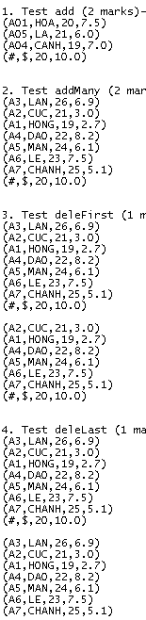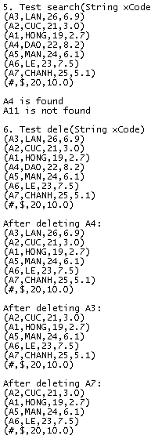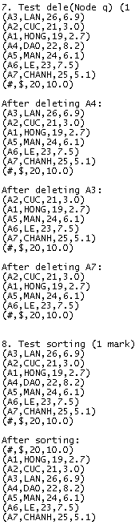

Notes:
In your output # will be replaced by your roll number (e.g. 00325)
$ will be replaced by your name and birth day (e.g. HungNV891029)
(HungNV891029 = Nguyen Van Hung 29/10/1989)

